**STEP 2**

HOW TO USE MICROSOFT SQL SERVER MANAGEMENT STUDIO TO CONNECT TO OUR REMOTE SERVER RUNNING THE SQL SERVER DATABASE MANAGEMENT SYSTEM

1. Before you connect to our Remote SQL Server at Montco, you must go through the Student Firewall.
2. When you have finished your work on our Remote SQL Server at Montco, you must logoff from the Student Firewall.
3. Start SQL Server Management Studio on your computer.
4. See the “Connect to Server” Window
5. Enter information as shown in the figure below: (IP: 38.115.60.103) (comma)(Port:1433)

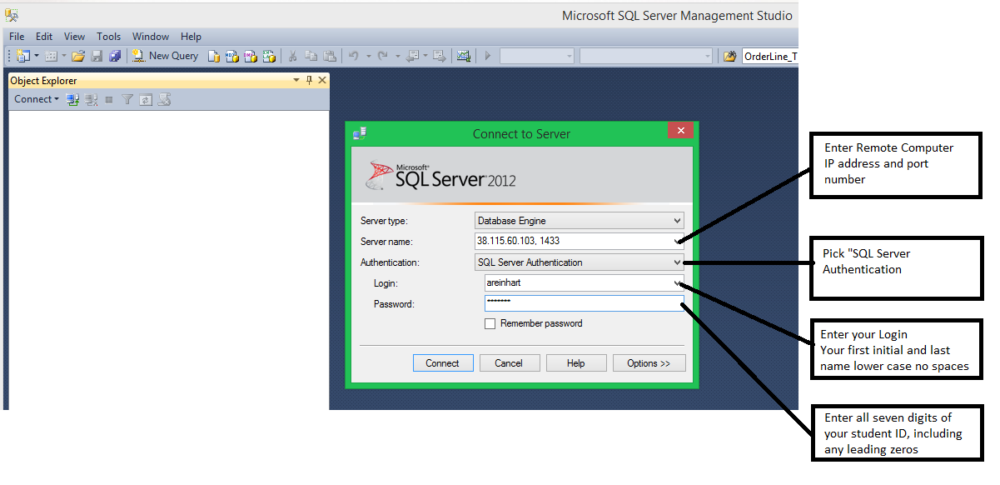

1. Press “Connect” and you will be directed to your connection of the SQL Server Instance running on the Montco Server as shown below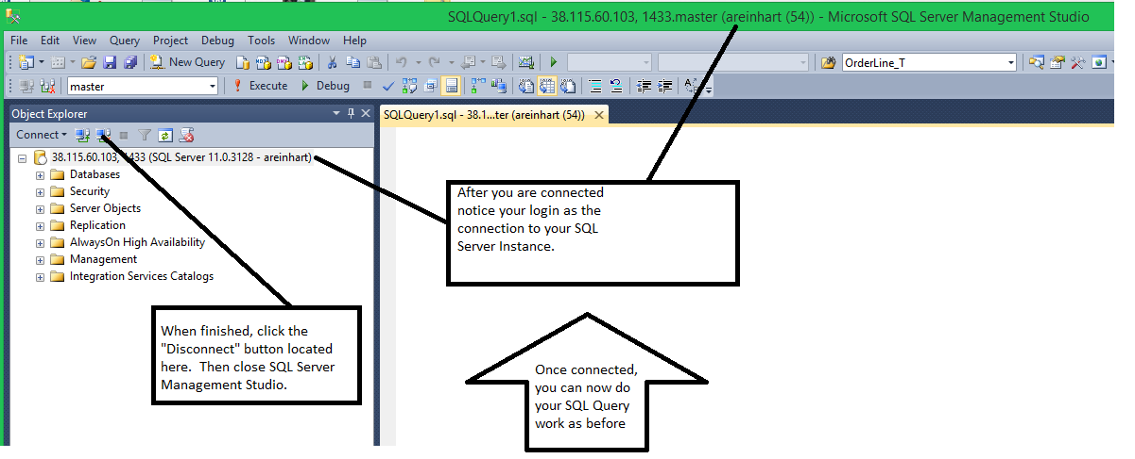
2. If you want to work on one of your existing databases, expand the Databases folder and locate your database.
3. If you want to create a new database, right click the Databases folder and select “New Database” to get the window shown below:

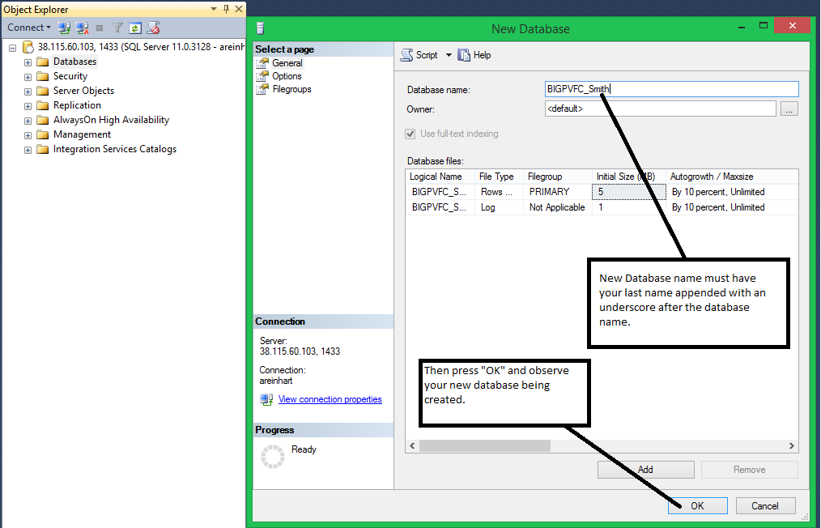

1. At this point you are now ready to work with your database using the New Query Window in which you will enter your SQL Statements.
2. Any scripts you create can be saved on your local computer in the appropriate folder
3. When you are finished, click the “Disconnect” button located at the top of the “Object Explorer” Window.
4. After you close SQL Server Management Studio, be sure to logoff of the Student Firewall.